Mr. Golub Unemployment Hearing Prep, July 7, 2025

Hello, please prepare Mr. Golub for his Unemployment Insurance Appeal’s Hearing for July 8, 2025 12:30. I would like you to prepare Mr. Golub for the hearing so that he can receive the benefits he deserves.

Provide the best possible argument for Mr. Golub: 1) explain what he needs to do to receive benefits, including specific language and pressure points; 2) explain all relevant arguments; 3) give the best arguments, including counter arguments; 4) draft a script for a mock interview that we can use to practice the interview (write a prompt that a speaking LLM can use to act as the judge, Workforce Services Officer (Kim), and anyone else who might take part in this interview. We are not sure if his former employers will be present, but consider what they would say if they appeared.

The following document contains: 0) appeals page screenshots; I) formal description of events; II) informal description of events (for internal use, not shown to Workforce Services); III) Letter sent to Workforce Services based on the description on §II; IV) notes for first interview with claim’s examiner; V) Follow-up Letter to Workforce Services (NOT SENT).

- Here is what the appeals page looks like:

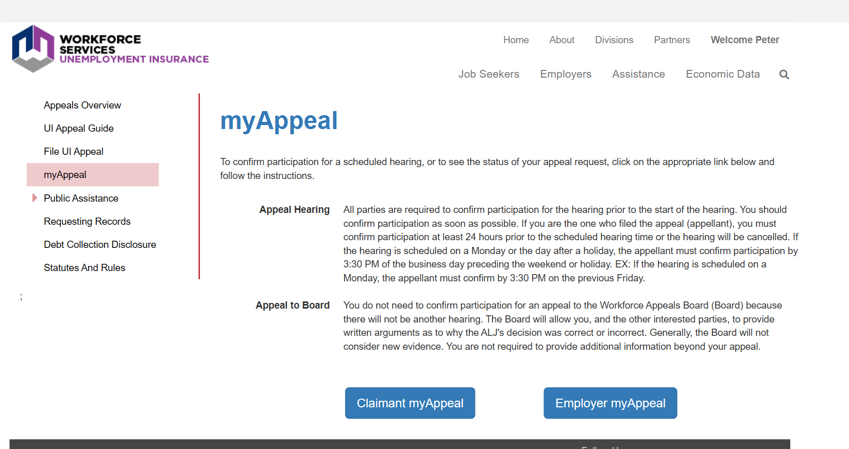

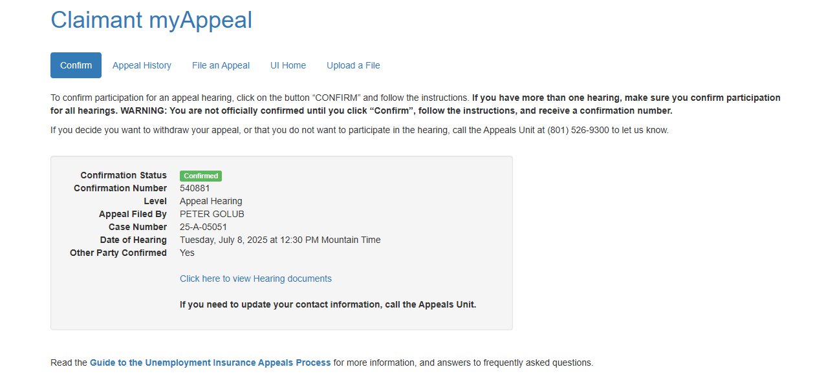
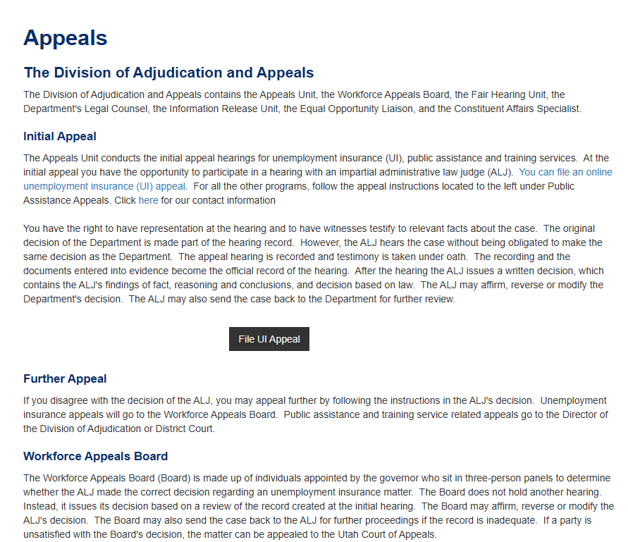

- Formal Description of Events

To better prepare, here is a formal description of what happened on and after May 5, which was when Mr. Golub’s Frontline work account was deleted and May 15, when his Granite email was deleted following his phone conversation with Brenda Byrnes, Associate Director (Secondary Teachers/Workers Comp, 385-646-4232) and Wyatt Bentley Associate Director (Elementary Teachers/Secretaries 385-646-4237) who were his bosses and who were responsible for terminating his position.

On May 5, 2025, Mr. Golub was denied access to Frontline and his account was functionally deleted. Here is the homepage:

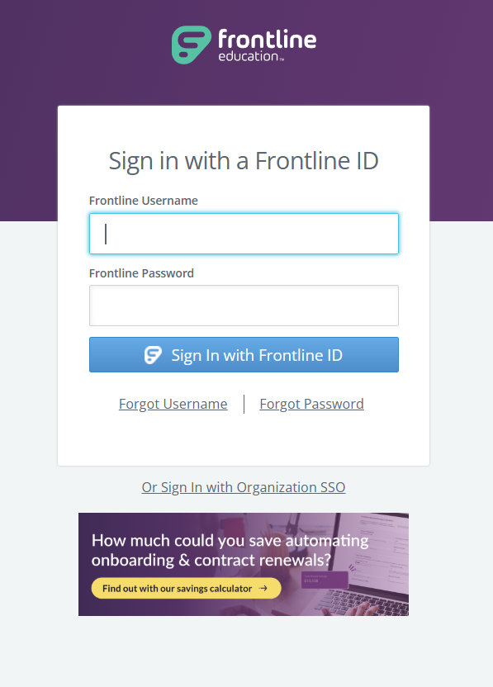

On May 5, his username no longer accepted. Frontline is used by the Granite School District to provide substitute teachers with jobs—to get a substitute teaching job, Mr. Golub would log in, choose an assignment, and do his job, which was to substitute teach both long and short term. Mr. Golub’s longest teaching assignment lasted from November 2023 to the last day of school (May 31); he also did short, one day assignments. When his Frontline account was deactivated, he could not work. This was a significant hardship, as he’d planned on working everyday till the end of the school year as he had the previous year, and was relying on this money—28 hrs a week at $32 hr (approximately $2,700). He sent an email to Wyatt Bentley and Brenda Byrnes (his employers), asking to have his account reactivated and explaining why the events of May 5 were not only cause for termination of his employment, but constituted harassment on the part of the vice-principal and principal (who’d called the police on Mr. Golub accusing him of smoking marijuana in his class of 1st graders—the police came with a K-9 unit and obviously didn’t find anything). NB although the Granite School District has kept Mr. Golub’s emails, his access to his email was also deactivated, so he has no access to them. This naturally harms his ability to argue his case, and if possible it would be good to say that none of the emails can be used against him as evidence, as he does not have access to this evidence. If he did have access, he would use them as they support his case, but as is, they can only hurt him. During his initial interview with Kim Lam, she quoted out-of-context passages from Mr. Golub’s emails that could be interpreted as “quitting,” but Mr. Golub emphatically insists he did not quit and was relying on the money he would have made not only in May but for many years to come. Mr. Golub was in the process of receiving his teaching license and had planned on teaching at the Granite School District long-term, so that termination of his employment is a major financial setback to his future plans.

Though Mr. Golub sent an email the day of the incident, he did not receive a reply until the following week i.e. he had already been denied a week’s worth of work. In his response, Wyatt Bentley completely ignored Mr. Golub’s letter and instead focused on an incident that had occurred three weeks prior, citing Mr. Golub’s use of the “f-word” and “teaching irrelevant facts about the use of AI in education.” Mr. Golub addressed these concerns arguing that they did not constitute grounds for dismissal (see previous description, letter). Mr. Golub has been greatly concerned with the complete breakdown of the Granite School District’s fiduciary academic responsibility to its students, especially low-income students who teachers openly admit they no long try to teach. Mr. Golub wrote at length to Mr. Bentley about the need to utilize AI tools to reverse the troubling trend of collapsing curricular aptitude in the Granite School District. Having stated his case in detail concerning Mr. Bentley’s accusations about an incident that had occurred back in April, Mr. Golub was under the impression that his account would be reactivated, and that he would be able to discuss his ideas for the utilization of AI in the Granite School District. Mr. Golub wrote a detailed document outline the current problems with k-12 education and how AI solutions, such as those offered by Sal Khan, Ethan Mollick, Richard Suskind, Christopher Summerfield, as well as Google’s Skill Share and Grow programs specifically designed for k-12 education. Mr. Golub set up a meeting with Mr. Bentley and Mrs. Byrnes for May 15.

On May 15 (i.e. 10 days after Mr. Golub’s account had been deactivated), Mr. Golub spoke on the phone with Mr. Bentley and Mrs. Byrnes. Mr. Golub was under the impression that they were going to speak about his ideas for the utilization of AI. Instead, the conversation was about the April incident that Mr. Golub had already addressed in length. Following this, Mr. Golub excused himself from the meeting, but said he would email his AI report to Mr. Bentley and Mrs. Byrnes. However, when he went to email his report, his email had already been deactivated. Despite his expectation that he would be allowed to continue teaching at the Granite School District, all of his accounts were deleted and his employment was terminated.

Several days later, Mr. Golub filed an unemployment insurance claim. His benefits were $6,097, $469 a week (see Notice of Monetary Determination). Mr. Golub was instructed to file his weekly employment claim to receive the benefits but has yet to receive any of his money. First, the payout was blocked because of possible “discharge.”

On May 13, 2025, Mr. Golub spoke with Workforce Services officer Kim Lam (see interview prep questions) and again repeated his claim that he did not believe that anything he did warranted his discharge. Officer Lam, quoted a part of his email back to him, but as Mr. Golub did not have access to the email, he could not confirm or deny that he had said that but argued that the quote did not support the argument that he’d been discharged. Officer Lam informed Mr. Golub that she needed more time to review the case.

On May 17, Mr. Golub received the decision of denial of benefits (see Decision of Denial) because he left his job voluntarily. This was quite surprising to Mr. Golub, as up until that moment all of his correspondence, including the interview with the Work Services officer concerned his possible discharge. Now the opposite was being claimed. Mr. Golub vehemently insists that he did not leave voluntarily—he did not deactivate his Frontline account on May 5 and his email on May 15. He was and remains willing to work as a teach in the Granite School District because as previously stated, Mr. Golub was in the process of trying to find a fulltime teaching position in the district. He had voiced his intention to send his AI Education report to Mr. Bentley and school administrators. He not only wanted to keep teaching, but had invested considerable time into what he believes is a crucial time and education and very much wanted not only to continue teaching but to reshape education by creating AI Tutor templates for individual students, incorporating Google’s AI education tools at the district level, and to work with Google and Granite to build a new, greatly improved education platform that would allow Granite to fulfill it’s fiduciary responsibility to its students. Thus, Mr. Golub did not leave voluntarily and believes he was terminated because of his vocal support of AI education, whereas the Granite School District recently implemented a policy forbidding students from using AI with severe penalties for students who even long into AI platforms like ChatGPT, Gemini, and Claude. Regardless of what the reason for his termination may be, Mr. Golub did not deactivate his Frontline account on May 5 or his email account on May 15, preventing him from working or even communicating as a Granite District employee. Because his accounts were deactivated by the Granite School District, it is the District not Mr. Golub that chose to terminate his job as a Granite School District teacher.

- Mr. Golub’s “Informal” Description of the Issue, June 7, 2025 (this was used to explain events and to write a formal letter—the letter is included after the explanation)

Below will fill you in on the task. It’s doozy:

You are doing this as a favor and you want him to get unemployment and feel like he’s being jerked around bc he worked for a dilapidating school district where he advocated for the use of AI tutors. They sacked him for “inappropriate” language i.e. for saying “I’m fucking Russian” in class, but this was ad hoc. They had in fact tried to fire him for countless other “language issues” which as someone who knows the district is hilarious. Indeed, your grandson stopped going to teach because one elementary school principle accused him of smoking cannabis with 1st graders. This you had to laugh at, which the poor little grandson did not find funny. Your daughter had a good heart, but her ex-husband had been weak and your grandson though intelligent and benevolent, has been pushed around since elementary school. Maybe that was why he suddenly felt he had to stand up for poor k-12 kids in awful school districts, and as before he was getting pushed around by both teacher and administrators who resented his attempts at trying to teach, where in these poor districts the whole thing is discipline. You’d never dream of sending your kids or grandkids for that matter to a public school, certainly not the districts your well-intentioned but soft grandson was devoting his time to.

worked for to adopt different teaching practices including AI. You are well aware for the dropping test scores and major problems with the school district and commend your grandsons attempt at trying to fix it by among other things advocating for the use of AI tutors. Though your son did go about it the entirely wrong way which is why he was put before not one but two “tribunals” and in the second case he refused to participate and was therefore fired. You are slightly annoyed but have agreed to write a letter to the unemployment office bc you think your grandson certainly qualifies for unemployment because he has not done anything wrong. In fact, as is often the case, he lost his job precisely because he was sticking up for the students and trying to reform the broken school district.

The story of the grandson is the following:

I lost my job in the second week of May, 2025. Today it is the first week of June and I have missed two weeks of unemployment pay now.

I applied for unemployment and am eligible to receive $6,097.00 (doc attached). I must file weekly claims showing that I’ve applied for at least four jobs, which I have done. I have applied for far more than four jobs a week. And most of my jobs are freelance, contract jobs which I can provide proof for, but I’ve certainly shown proof for four large company employers which their system requires.

In any case, I’ve submitted my weekly unemployment documentation for two weeks now, but have yet to receive any funds. Having checked the website I see that there is an issue preventing dispersal of funds:

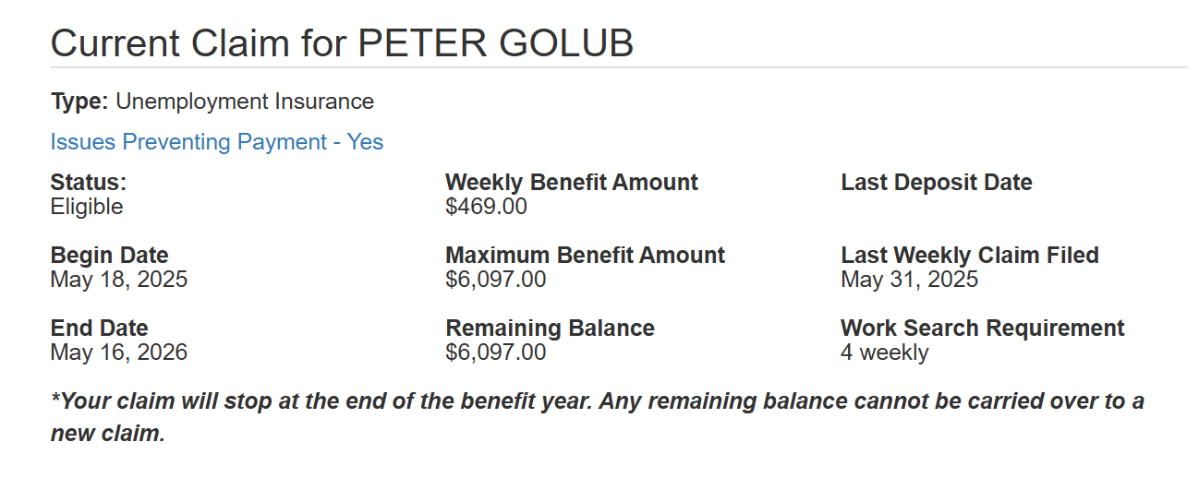
When I click on this link I see the following:

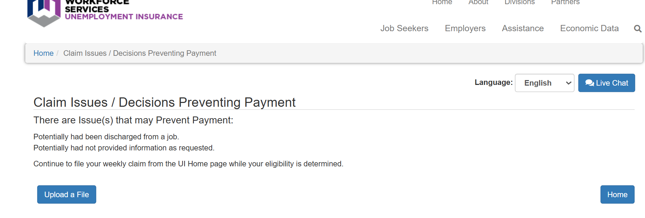

I would like you to write a letter to the unemployment office addressing each of these issues. Unfortunately, there is no other information detailing what they mean by “not provide information” but I do think I know what they mean by “discharged” because I did select possible discharge when I filled out the form. This was a mistake on my part and I will explain why I marked it below. But the fact that I do not have access to the form or any documents I can use to explain my position, I would like to send them this letter. There is the option of uploading a file, but it says nothing about what this file should be or what they want from me. I have waited for two weeks and figured they would send some other correspondence but they have not. So this letter will be my first attempt at trying to explain my position, to argue that I am absolutely deserving of unemployment, and that I am happy to provide whatever additional information they require. Having been to this unemployment office years ago, i honestly think they’re just being lazy. Please, Grandpa Albert Krieger make these people pay me or at least send me an email explaining why they are not paying me.

I really wish the Granite School district hadn’t immediately deleted my email, as it contained all my emails and correspondence, but the TLDR is that I was trying to teach in a school district where most had stopped. I was fired on May 5 because a principle accused me of smoking marijuana with 1st graders. It was the most insane thing I’ve ever been accused of, and they have accused me of some insane shit because I am a substitute teacher and must deal with the absolute craziest teachers and administrators on an almost weekly basis.

Until I realized the insane incompetence and straight up abuse wasn't just like an individual teacher or principal thing, or even a school thing, but a district wide thing. Of course, the poorer the school is the worst the problems, to the extent that I'd say that about half the students in the district aren't being taught anything--it's basically a jail, with multiple locks on all the doors, dividers between parts of the school, “panic rooms” which is essentially solitary confinement, teachers don't even pretend to teach sometimes, just giving the kids cheap chromebooks and as long as they don't get up or cause a ruckus, they can play free games on their computer. I was supposed to sub for an English class for five weeks for a woman getting knee surgery. The district doesn't pay subs or teachers for any extra prep e.g. ghosting the teacher for a day since I'm basically gonna be picking up where she left off, and boy... it was December so that kids had just all taken their government aptitude tests and although this was a class composed of 14-15 year olds, the mean reading level was the 5th grade, which means that there are kids in there that are literally illiterate, not just in English but in Spanish as well. So I do what I always do and bring lots of interactive crap, costco bags of hi-chews, and try to get them to actually do some work. I even assign them homework, which is essentially is just the next half-page of their binders. Prior to me, class consisted of pledging allegiance to the flag, school propaganda, CNN propaganda, and then the teacher would project the answer key on the board and sort of read it, i.e. they have a worksheet with multiple choice and fill -in-the-blank questions. On the answer key, “science” had been spelled “seance,” which I thought was hilarious and pointed it out. The teacher was a big confused, then laughed, then crossed out seance and wrote in “sceince,” which the six of the 35 kids dutifully copied onto their worksheet. Great. At this point in time, the teacher has given me printouts of their aptitude tests, which are just piled into the trash that looks like it hasn't been taken out for many days, since the trash bin can barely be seen under the pile of empty dorito bags and school work, which naturally half the kids throw away, sometimes as soon as she hands it to them. I look at this whole thing and am just like, “Damn, and this is technically supposed to be the flagship school, as this is the Granite Jr. High, which was built during the Depression and is now in a low-income neighborhood two blocks from State St. and the “Chinatown” strip club. In anycase, I try to teach, and some of the kids say they've been assigned homework or been asked to read in class, etc. There is also a large contingent of little gangsters who talk shit in Spanish, but I know Spanish and so I try to teach them some basic Spanish grammar, as a baseline, and some of them really take to it and I give them some glitter pens (as it was getting near Xmas, and I basically try to bribe the kids as much as I can). The next day, this 6'6 hulk of a woman comes into class while I'm trying to teach and has like 10 glitter pens per fist, and brings them to me with an element of pride, the way a cop might bring in like a bag of cocaine or something. Ok, this is getting way too long... so TLDR, I start butting heads with the administration, and get cited. The school VP has like cops escort me off the premises and won't let me grab all the crap I'd brought in for interactive play (including an old hand carved Russian chess set, a Pono uke, old cameras from the DDR, etc.) It takes me weeks to finally get my shit back. I go before a board and there's a lengthy investigation and the district decides that although I did use inappropriate language (this was the official charge), I was genuinely trying to teach, oh and some of the kids who liked me got into like a fight with some of the snitches, so there was an unofficial suggestion that I like incited violence.... Anyway, I'm allowed to continue to sub but not at that jr. high. Fine. Also, these completely sadistic and incompetent Sped teachers at the high school closest to me and which is the second best school in the state (Karl Rove's alma mater) where I worked for an entire year with Sped kids, these women also were like not a fan of my liberal approach to pedagogy--all I'm trying to do is shift from enforcing Prussian style discipline and love of country to teaching kids how to read and that like apes are different from monkeys because they don't have tails, like simple dumb facts and yes some history and even biology. Because the teachers are either complete idiots or completely burned out saying that “since the pandemic the kids have become unteachable.” Like there is scarcely a good teacher left, and the ones that are still trying, have basically resigned themselves to losing the battle on all fronts, the schools are doing nothing knew, the students' EQs and IQs are in the toilet, and it really is beginning to look like a prison compound, with lots of keycards and badges, which if you don't have can get you escorted by the cops to the office where you are treated like a little kid for not following protocol. The whole fucking system is a mess. Oh, and they've of course made AI illegal, like even using an LLM on school grounds can get you suspended, which is sheer insanity. So I start doing research and putting together a model for who AI can be used in schools, which tools would be very easy to apply (Notebook LM, Perplexity, and Anthropics master prompting, etc.) and how ultimately each of these kids could today have their own tutor that would know their background and learning style and know Spanish. Oh, of course pretty much all the teachers are still obese white women who know nothing, including Spanish. But you can imagine how these people are reacting to me. I wear a suit and tie everyday to work, while they're in Walmart jeans talking about the last Kary Perry song, I'm talking about how given an coherent and easy-to-use RLHF template, each student can have an AI tutor that would integrate all their studies with each students unique learning styles and interest. And so, last Monday, I go into work. And I'm just not going to say anything about this class because it was probably the worst one yet and the school was so incompetent (I'll just attach my desription to this email in case you're interested). But so by the end of second period the vice-principal, principal, and a cop in all his kevlar-vested, batman utility belt glory rush into the class, and don't tell me anything of course, but just ask me to follow them to the office where they lock me in a room and start questioning me about why there is marijuana smoke coming from the class. Again, I'm just not gonna get into my reaction. This is the most insane thing I've heard yet. The cop to his credit said he didn't smell anything and I didn't have any drugs on me so there wasn't much he could do. He leaves but this just pisses them off even more. So they send in a K-9 unit, which also doesn't find anything. And so I teach for a couple of more classes, and there are just countless women with walkie-talkies going in and out of the class. Oh, and this is an elementary school, so the kids I allegedly smoked weed with were in the first grade. At fourth period, the principal comes in again and says that do to my erratic behavior, I am required to give her a blood sample. At which point, I grew very quiet and still--knowing I will go to prison for what I want to do, so I got my shit and left.

Of course, when they forced me to do a second “review” it had nothing to do with this school, since it was clearly madness. However, they brought up an earlier day when I taught in April. Several students had tried to leave the class after taking a Spanish test, and as I did not allow them to they began making a ruckus and eventually, they ended up doing a dance competition which I presided over. What else could I do. They did head shoulders knees and toes for some 20 minutes until some teacher came in and said they were making too much noise. This had happened weeks before May 5 but this was the reason they decided to suspend my account, not the completely insane accusation of the truly evil elementary school. I had written a very long explanation of what happened at the elementary school and how the principle and vice principle picked on the kids and how my standing up for them had angered them, but I don’t want to get into it. This is already much too long.

I have no idea what the issue is but it could be just that I marked that I might have been discharged even though I’m not even sure what that means. I know I worked harder than 90% of the teacher in that school district and students repeatedly came to me asking for me to be their home teacher, telling me about how awful it is to be in these schools, that have absolutely given up teaching, with teachers that regularly call the kids unteachable and honestly are the worst teachers I’ve ever seen, with absolutely no credentials or credential from fake universities. The two biggest degrees I’ve seen in these classrooms are from Utah Vally College and Pheonix University. These teachers can’t spell words like “science” and don’t know what “pedagogy” means. These are teachers who don’t know the definition of pedagogy. Obv this isn’t all of them, but it seems like the statistics are true… the absolute lowest scoring people who do actually take real tests like the GRE the people who go into education score the lowest, but these people aren’t just dumb they are so lazy. I know I never finished my phd at Berkelely but I do have an MA and an MS from Columbia and Berkeley. I know I have let our family down by going into publishing poetry and fiction instead of becoming a lawyer, and now am here begging for your help. But could you draft a letter that speaks the language of the unemployment office that gets them to make a decision—either give me the money or tell me what you want, but this continual insistence I keep filling weekly claims without receiving any result is driving me crazy.

- Letter Sent to Workforce Services June 2, 2025 (see attachment)

Salt Lake City, UT 84145-0277 Re: Peter Golub – SSN: 528-91-2127 Claim Effective Date: 05/18/2025 Request for Immediate Resolution of Payment Hold Date: June 2, 2025 Dear Claims Administrator: I am writing regarding the unexplained hold on Mr. Golub’s unemployment insurance benefits. Mr. Golub has been approved for benefits totaling $6,097.00 ($469.00 weekly for 13 weeks) but has received no payments despite filing all required weekly claims and job search documentation for the past two weeks. The online system indicates an issue preventing payment, citing “discharged” and “not provide information” as concerns. I am writing to address these issues directly and request immediate release of the benefits owed to Mr. Golub. First, regarding the discharge issue: Mr. Golub was NOT discharged for misconduct. His separation from Granite School District was the culmination of philosophical differences regarding educational methods and his advocacy for educational reform, including the integration of AI tutoring systems to address the district’s documented literacy crisis. While the district may characterize the separation differently, there was no misconduct, no violation of law or policy, and certainly no behavior that would disqualify him from unemployment benefits under Utah law. The incident cited by the district—students conducting a brief dance activity after completing a Spanish test—was a classroom management decision made in the moment and hardly constitutes dischargeable misconduct. The students wanted to dance, and Mr. Golub let them as they had completed their test. The more serious allegation of using the f-word is also not reason for dismissal, as Mr. Golub had used it in reference to himself not a student. This was regrettable but seeing as how longterm teachers regularly yell at students and use far more conduct toward students, this is not the type of offense that would warrant a discharge. Unfortunately, Mr. Golub no longer has access to his Granite School email or profile, but it should be noted that multiple students wrote to the district with letters of praise, citing Mr. Golub’s unprecedented attention to education and, perhaps more importantly in this context, respect for students who are regularly referred to as “unteachable” and “lost” by long-term faculty who are “burned out.” Mr. Golub was not burned out and continues to be passionate about public education. This passion should be commended not penalized. Second, regarding information not provided: Mr. Golub has submitted all requested documentation through your online portal. If additional information is required, your office has failed to specify what is needed. This lack of communication while continuing to require weekly filings without payment is unacceptable and potentially violates Utah’s unemployment insurance regulations requiring timely determinations. Therefore, I request the following immediate actions: 1. Release all pending benefit payments immediately, as no valid reason for withholding benefits has been established. 2. If benefits cannot be released immediately, provide within 48 hours a detailed written explanation of: o Exactly what information or documentation is required o The specific statutory or regulatory basis for withholding benefits o A clear timeline for resolution o The appeals process if benefits are denied 3. Confirm receipt of this correspondence and provide a direct contact for resolution of this matter. Mr. Golub has met all eligibility requirements: he lost his job through no fault of his own, he is able and available for work, and he is actively seeking employment (exceeding the four weekly applications required). He has two advanced degrees from Columbia and Berkeley and devoted two years to attempting to improve educational outcomes for underserved students in your state. He deserves the benefits he has earned. The Department's continued delay in payment while requiring ongoing compliance with filing requirements is causing significant financial hardship. Utah law requires prompt payment of benefits to eligible claimants. Each day of delay compounds the harm to Mr. Golub. I trust this matter will receive your immediate attention. Should you require any additional documentation or clarification, please directly respond to this correspondence or contact Mr. Golub at 801-618-7609. We are prepared to provide any reasonable documentation to expedite this process. However, absent a legitimate basis for withholding benefits, which has not been provided, we expect immediate release of all benefits owed. Respectfully submitted, Peter Golub 3921 south 2000 east Salt Lake City, UT 84124

- Interview June 10

I’d like you to write a 1st-person follow-up letter to the one already sent (Letter to Utah Department of Workforce Services). In this document, we will provide first person answers to specific questions the Utah Department of Workforce Services might have about: nature of the separation; circumstances; “misconduct” element; the issue of whether Golub quit or were fired; and any other issues they might raise.

Here is what I told him earlier, but there might be additional useful information. We want to use this to write a first-person letter. I’ve provided some examples of how he might answer that can be used in our draft. Thx!

- Utah unemployment law distinguishes between being “discharged” (fired/let go) and “quitting” (voluntarily resigning).
- The reason for separation is critical: If you were discharged for “misconduct,” you may be disqualified. If you quit, you must show “good cause” related to the job (not just philosophical differences) to qualify.
- The state is looking for facts, not lengthy stories or editorializing. Keep your answer focused, factual, and professional.

Here are some possible ways to frame the explanations for the four above points

1. Clarify the Nature of Separation

Based on your account, it appears that you left during a meeting after being accused of inappropriate conduct, but you were not formally fired on the spot. This is sometimes called a “constructive discharge,” or “quit in lieu of discharge.” In Utah, this can be a gray area.

How to explain:

“I was called into a meeting with administrators regarding concerns about my teaching style and language. During the meeting, I was accused of inappropriate conduct, which I disputed. I was upset by the accusations and, feeling that the situation had become untenable and that I was being unfairly treated, I left the meeting and did not return to work. I was not formally terminated at that moment, but I no longer had access to my accounts and was not contacted to return.”

2. Describe the Circumstances Factually
Focus on the facts, not your opinions about the school or colleagues.
How to explain:
“There were disagreements between myself and the administration regarding classroom management and communication style. I acknowledge that I used inappropriate language on two occasions, which I regret and for which I apologized. However, I felt that the administration’s response was disproportionate and that I was being singled out unfairly. The final incident involved an accusation that was not substantiated, and after that meeting, I chose to leave.”
3. Address the “Misconduct” Element
Utah will want to know if you were let go for “misconduct.” Misconduct is generally defined as a willful or deliberate violation of the employer’s rules or standards.

How to explain:
“While I did use inappropriate language, it was not directed at students but was a self-referential comment made in a moment of frustration. I apologized for this. I did not violate any other school policies intentionally, and I did not engage in any illegal or dangerous behavior. The other accusations were not substantiated by any evidence.”
4. If Asked: “Did You Quit or Were You Fired?”
If you left during a meeting and were not formally terminated, you can say:
“I left the meeting because I felt the accusations were unfair and the work environment had become hostile. I was not told I was fired, but I was not contacted to return, and my access was revoked.”

Sample Answer for the Interview
“My separation from my last employer was due to a series of disagreements with the administration about classroom management and communication style. I was called into meetings regarding concerns about my language and teaching methods. I acknowledge that I used inappropriate language on two occasions, which I regret and for which I apologized. During the final meeting, I was accused of inappropriate conduct that was not substantiated. Feeling that I was being treated unfairly and that the work environment had become hostile, I left the meeting and did not return. I was not formally terminated, but my access to school systems was revoked and I was not contacted to return.”

Additional Tips
- Avoid blaming others or venting. Keep your tone neutral and professional.
- Be honest, but concise. Focus on what you did, what you regret, and what steps you took to address concerns.
- If asked if you would return: “Given the circumstances, I do not believe it would be productive for me to return to that environment.”

Workforce Services Appeals Interview Instructions (YouTube Transcript)

Your unemployment benefits
hearing is coming up soon to help you prepare.
Here's a list of important questions and answers about the hearing process.
The most important thing to do
is to confirm that you'll participate in the hearing.
You should do this as soon as possible.
What is the process to confirm?
My phone hearing will send you a hearing packet that contains the date
and time of your phone hearing and instructions
about how to confirm that you'll participate.
We'll send it to your inbox if you communicate with this electronically.
If not, we'll send it to you through regular mail.
When you receive the packet, you should immediately follow the instructions
inside it to confirm that you participate in your scheduled hearing.
The instructions detail how to confirm online
and how to confirm by phone if you don't have access to a computer.
I filed the appeal.
What happens if I don't confirm my hearing at least 24 hours before the hearing?
If you filed the appeal and you don't confirm
as instructed, will cancel your hearing.
If we cancel your hearing, you may or may not be allowed to have
a new hearing, depending on your reason for failing to confirm.
It's definitely in your best interest to confirm the hearing
as soon as you receive the hearing packet.
I didn't file the appeal but was notified of a hearing.
Do I need to confirm my participation?
If you didn't file the appeal but want to participate in the hearing,
call the number to confirm before the hearing starts.
If you don't confirm before, the hearing will hold the hearing without you.
What if there's
an emergency and I need to reschedule?
You must make your very best effort to attend the hearing.
Remember, it's a phone hearing, and you won't have to
leave your home or office to attend.
If you have no other option but to reschedule your hearing,
you must call the appeals unit right away to explain.
Don't wait until the time of the hearing to ask to reschedule the appeals unit.
Phone number is 8015269300.
We'll decide if your reason for rescheduling is allowable.
If so, we'll reschedule your hearing.
If not, we won't reschedule it.
This hearing packet is several pages long.
Do I really need to review all of these documents? Yes.
You absolutely should review the entire packet.
Besides instructions on
how to confirm your hearing, it contains other important information.
For example, it lists all the issues that need to be resolved.
It also includes the evidence used to make the original benefits decision.
This evidence is called exhibits,
and there may be several exhibits included in your packet.
Exhibit numbers are shown at the bottom of each page.
Remember to keep scrolling down in the electronic version of the packet
until you see the actual exhibits so that you can review, then review
all of the information in the packet carefully
and be sure it is available at your hearing.
Can I represent myself at the phone hearing or do I need a lawyer?
The hearing process is designed
for you to represent yourself without the need for a lawyer.
Most people represent themselves.
However, you may choose to have a lawyer
or another person represent you at the hearing.
Remember, it's your responsibility to find a representative,
and it's also your responsibility to pay for their services.
Can I
call witnesses to testify at my hearing?
Yes, you can. Your witnesses should have
direct knowledge of the issues about which they testify.
The judge will decide which witnesses will be allowed to testify.
And be sure your witnesses are available until the hearing is over.
Can I send additional information to be considered at my phone hearing?
Yes. You may send additional information to be considered at the hearing.
The judge will decide whether it will be allowed as evidence.
Please carefully review your entire hearing packet first
to verify that the information isn't already included there.
Keep in mind
that you must provide the information at least three days before the hearing,
and you must send it to the appeals unit and the opposing party if there is one.
What will happen at my phone hearing?
If you follow the instructions in the hearing packet and confirmed
your hearing, the judge will contact you by phone
on the scheduled date and time.
The judge will outline the hearing process and explain the issues
scheduled for discussion.
They'll hear testimony from witnesses under oath, you or your representative.
If you choose to have one, may question any witnesses.
Remember, even though it doesn't take place in a courtroom,
it is still a real hearing and is legally binding.
How will I know what your decision is?
We realize that you'll want to receive our decision as soon as possible.
We'll send you a written decision within two weeks of your hearing.
What if I don't agree with your decision?
If you don't agree with our decision,
follow the directions and the decision letter to take further action.
We wish you the best of luck at your hearing
and hope this video has answered your most important question.
Remember, this video does not cover everything about the hearing
or the appeals process.

- Follow-up Letter to Utah Department of Workforce Services (Not Sent)

Dear Claims Examiner:

I am writing to provide clarification regarding my separation from Granite School District, as requested. My attorney submitted a letter on my behalf on June 2, 2025, and I understand you may need additional information directly from me to process my unemployment claim.

**Nature of Separation**

I was called into a meeting with administrators on May 15, 2025, regarding concerns about my teaching methods. During this meeting, I was accused of inappropriate conduct, which I disputed. Feeling that the situation had become untenable and that I was being treated unfairly, I left the meeting and did not return to work. I was not formally terminated at that moment, but my district email access was immediately revoked and I was not contacted to return. While I left the meeting of my own accord, I believe this constitutes a constructive discharge given the hostile circumstances.

**Circumstances of Separation**

There were ongoing disagreements between myself and the administration regarding classroom management and teaching methodology. I acknowledge that I used inappropriate language on two documented occasions - specifically, saying "I'm fucking German" in class. I regret this lapse in judgment and apologized for it. However, I felt the administration's response was disproportionate. The final incident on May 5 involved an accusation of drug use with students, which was investigated by law enforcement including a K-9 unit and found to be completely unsubstantiated.

**Regarding Misconduct**

While I did use inappropriate language, it was a self-referential comment made in frustration, not directed at students. I did not violate any other school policies intentionally, and I did not engage in any illegal or dangerous behavior. The serious accusation made on May 5 was investigated and no evidence was found. I had previously gone through one district review for the language issue, was cleared to continue teaching, and then was subjected to a second review for an incident that had occurred weeks earlier.

**Did I Quit or Was I Fired?**

I left the May 5 meeting because the accusations were demonstrably false and the work environment had become hostile. I was not explicitly told I was fired, but I was immediately locked out of all district systems and was not contacted to return. Given these circumstances, I believe this was effectively a termination, though I acknowledge I physically left the meeting.

**Additional Context**

Throughout my two years with the district, I maintained a professional demeanor, wearing a suit and tie daily and focusing on improving educational outcomes for underserved students. While I advocated for educational reforms including the use of AI tutoring systems, this advocacy was always conducted professionally and with students' best interests in mind. My separation was not due to performance issues but rather philosophical differences about educational methods and an escalating pattern of what I perceived as retaliation for my advocacy efforts.

I am ready and willing to work, actively seeking employment, and believe I meet all eligibility requirements for unemployment benefits. I separated from my position due to circumstances that made continued employment untenable, not due to any disqualifying misconduct.

Thank you for your consideration. Please contact me if you need any additional information.

Sincerely,

Peter Golub
3921 South 2000 East
Holladay, UT 84124

